**University of Engineering & Technology, Mardan**

**Department of Computer Science**

**Lab # 10**

**Name:** Muhammad Haris

**Registration. No:** 20MDBCS087

**Subject:** Data Analysis Lab

**Semester:** 8TH

**Date:** 4th May, 2024

**Submitted To:** Dr. Tariq Sadad

**Dataset**

The dataset used is “**SalesData.xlsx**“. Upload the dataset in Power BI and refer to the dataset to follow along with the below-given sections of the article.

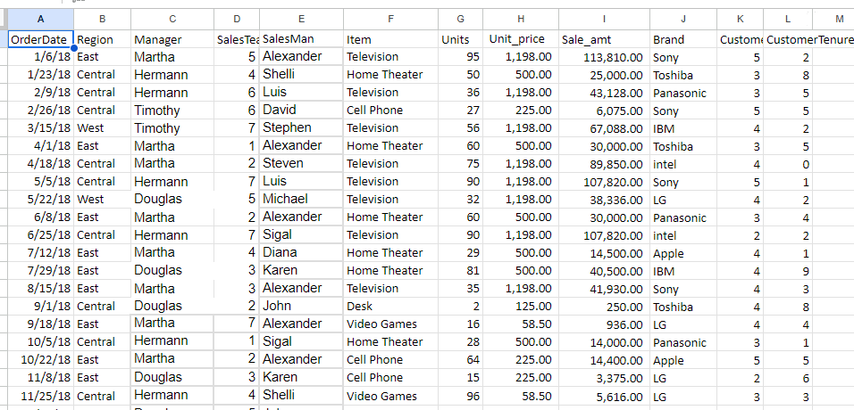

**Data**

We will be working with “SaleData.xlsx” data with data fields as shown in the above image. The major variables used to show the charts are as follows.

* Item: This is the item name. This is the variable for which the sale is shown in the form of pie or donuts.
* Brand: This is the brand name for any particular item. One item can belong to different variety of brands.
* SaleAmt: This is the total amount sold (shown in Indian “Rs”).
* Region: Whether the sale is in the “Central”, “East” or “West” region.

**Load Data in Power BI Desktop**

**Open Power BI Desktop**

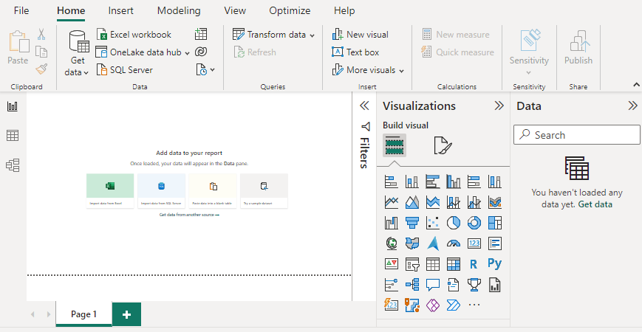

**Click the “Get Data” option and select “Excel” for data source selection and extraction.**

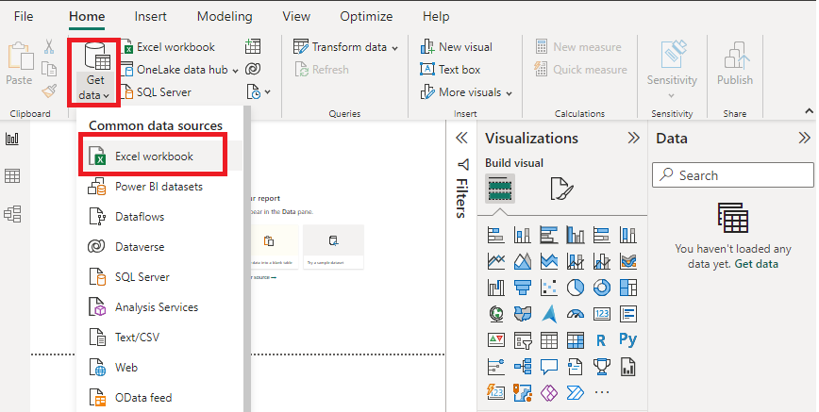

**Select the relevant desired file from the folder for data load. In this case, the file is “SaleData.xls”. click the “Load” button once the preview is shown for the Excel data file.**

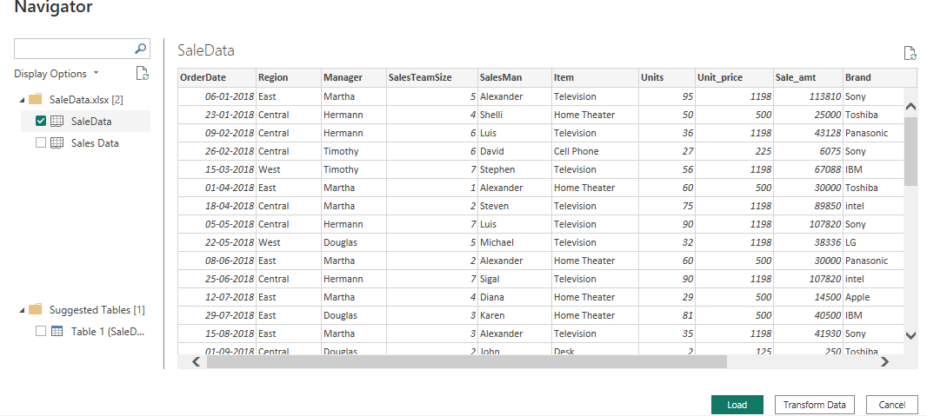

**The dashboard is seen once the file is loaded with the “Visualizations” Pane and “Data fields” Pane which stores the different variables of the data file.**

**Data Pane:**

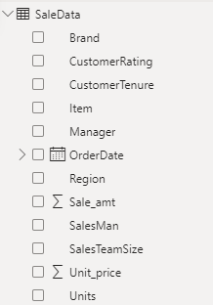

**In the “Visualizations” pane, we can select the chart type needed for our visual representation of business data. In the following image, the red-colored square represents the “pie” and “donut” chart that can be dragged for the “Report” view for further process.**

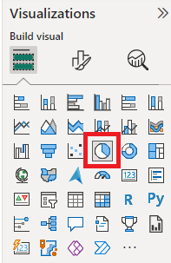

**Pie Chart in Power BI**

**Drag the Pie chart icon from the “Visualizations” pane to the Report view Canvas of Power BI desktop. The initial pie chart in the canvas looks like the following.**

**Initial chart:**

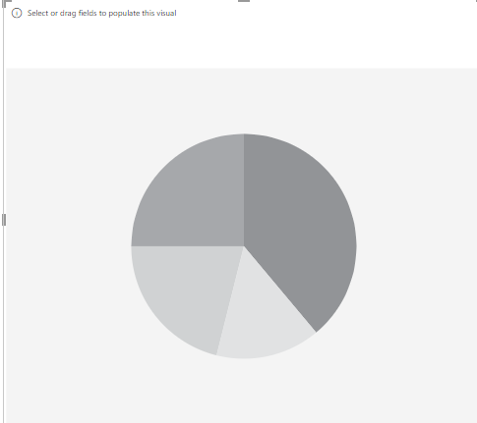

**In this lab, we will learn to get a pie chart that shows the Sum of “Sale_amt” based on different brands' “Brand”. Set the “Visualizations” pane as shown below by dragging the relevant fields from the “Data” pane from the “SaleData” dataset as mentioned earlier in the previous section of this article.**

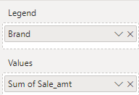

**Output: We get the following pie chart which provides details about different brands in multiple colors with the percentage value contribution for each brand**

